OUTPUT :

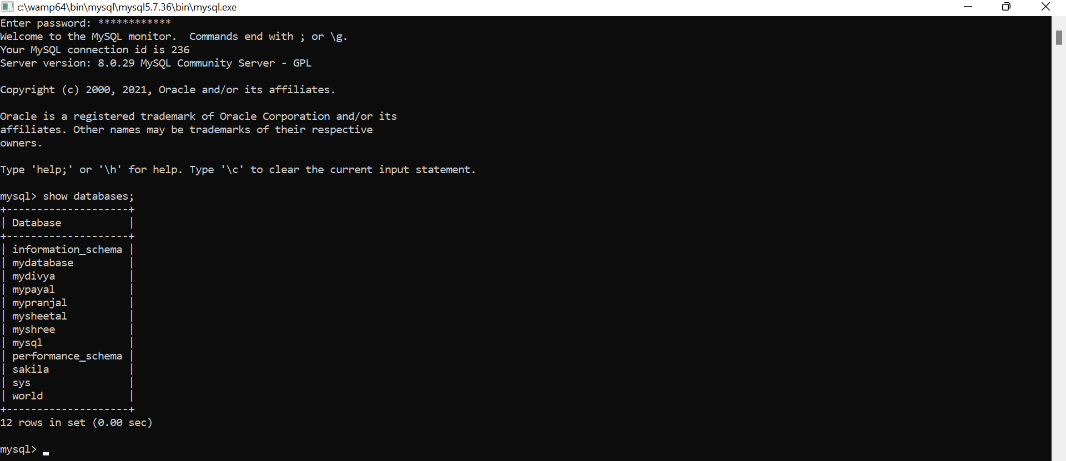

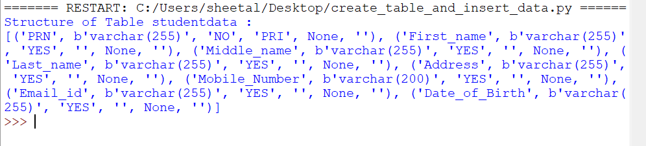

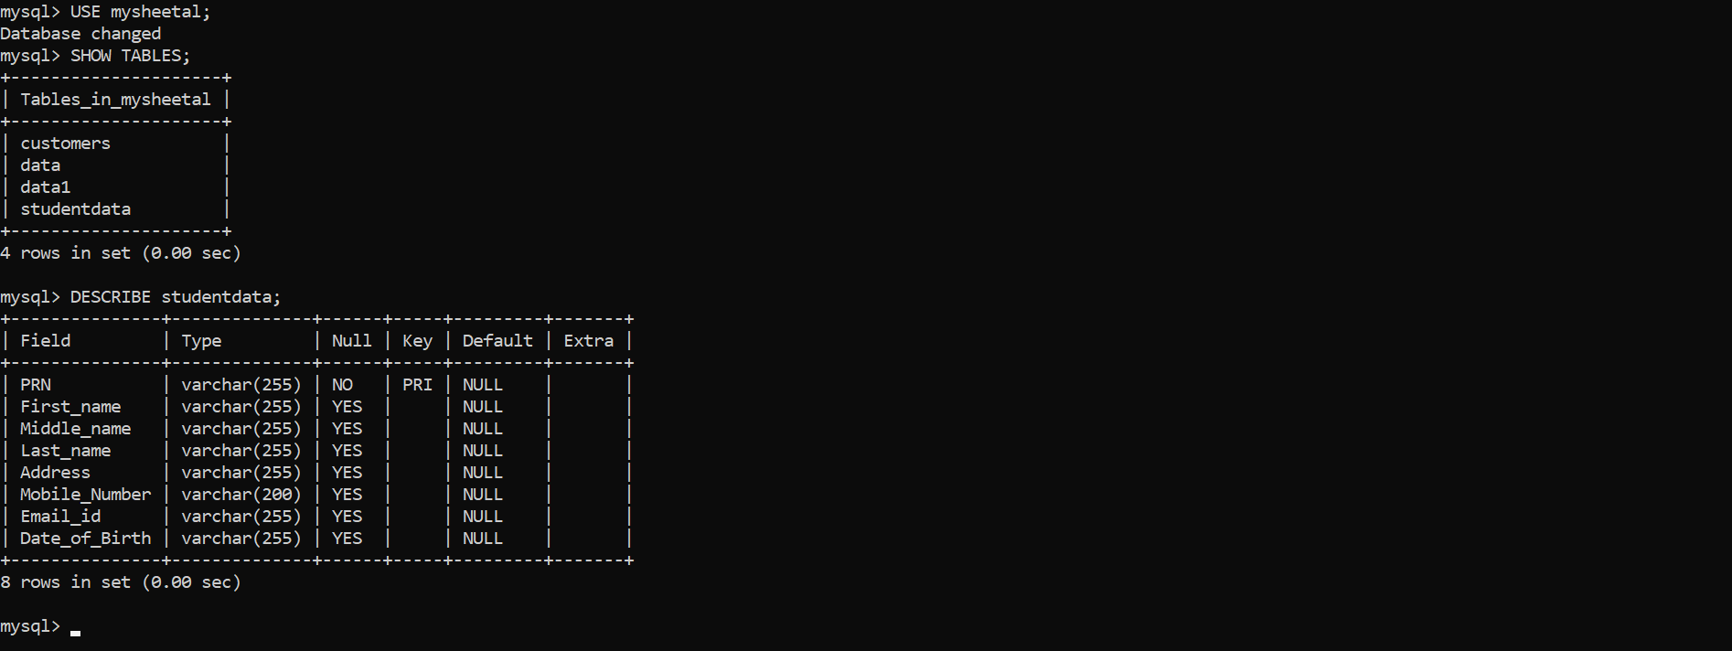

1)Display the name and ages of all the students

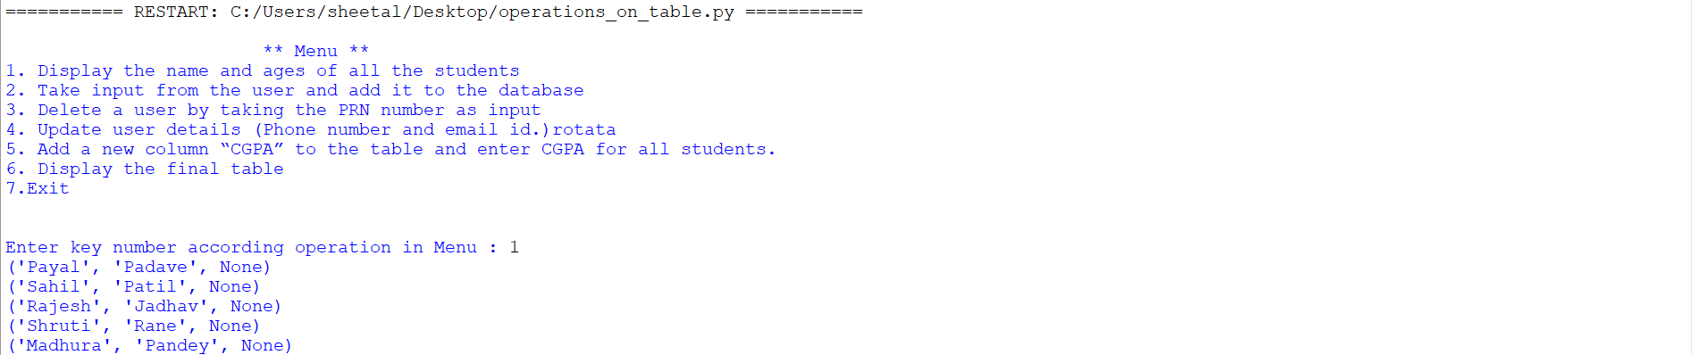

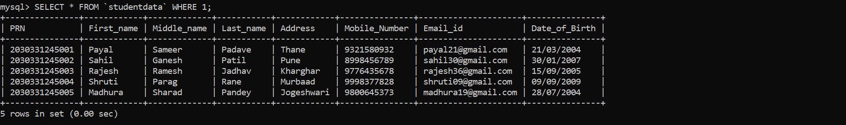

2) Take input from the user and add it to the database

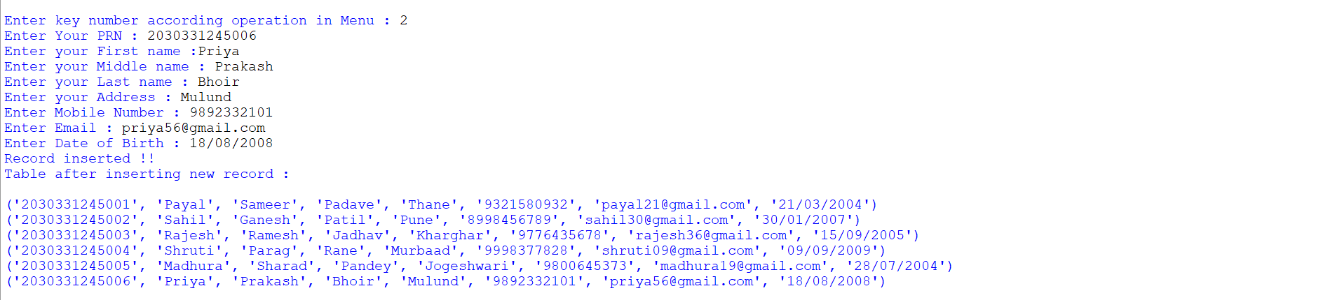

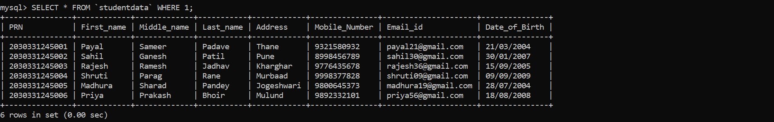

3) Delete a user by taking the PRN number as input

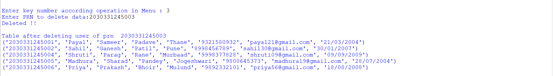

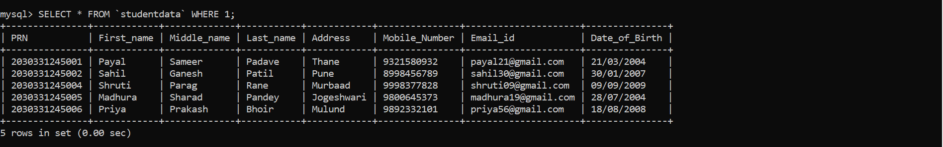

#Again I insert row of PRN 2030331245003

4) Update user details (Phone number and email id.)

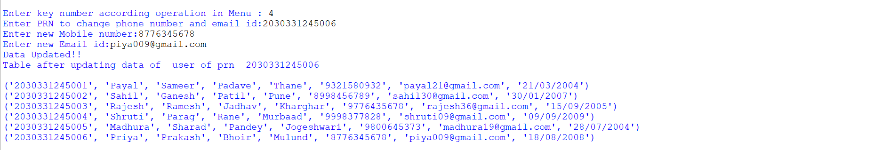

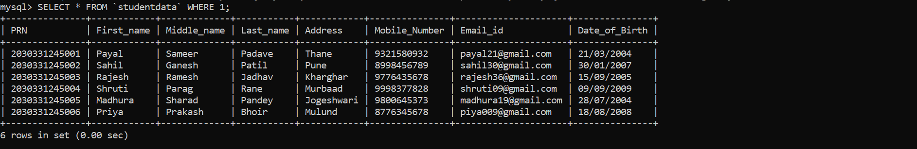

5) Add a new column “CGPA” to the table and enter CGPA for all students.



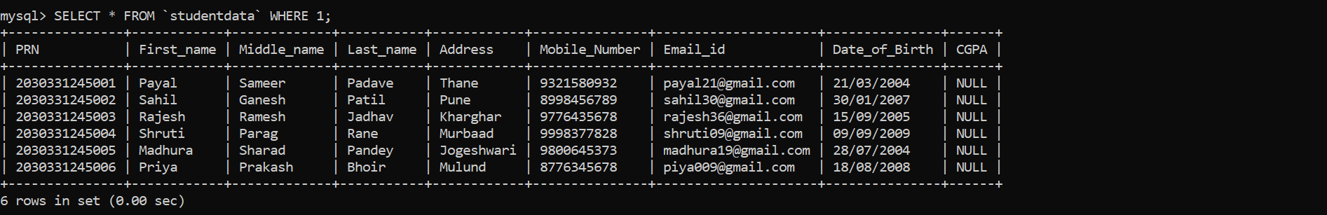

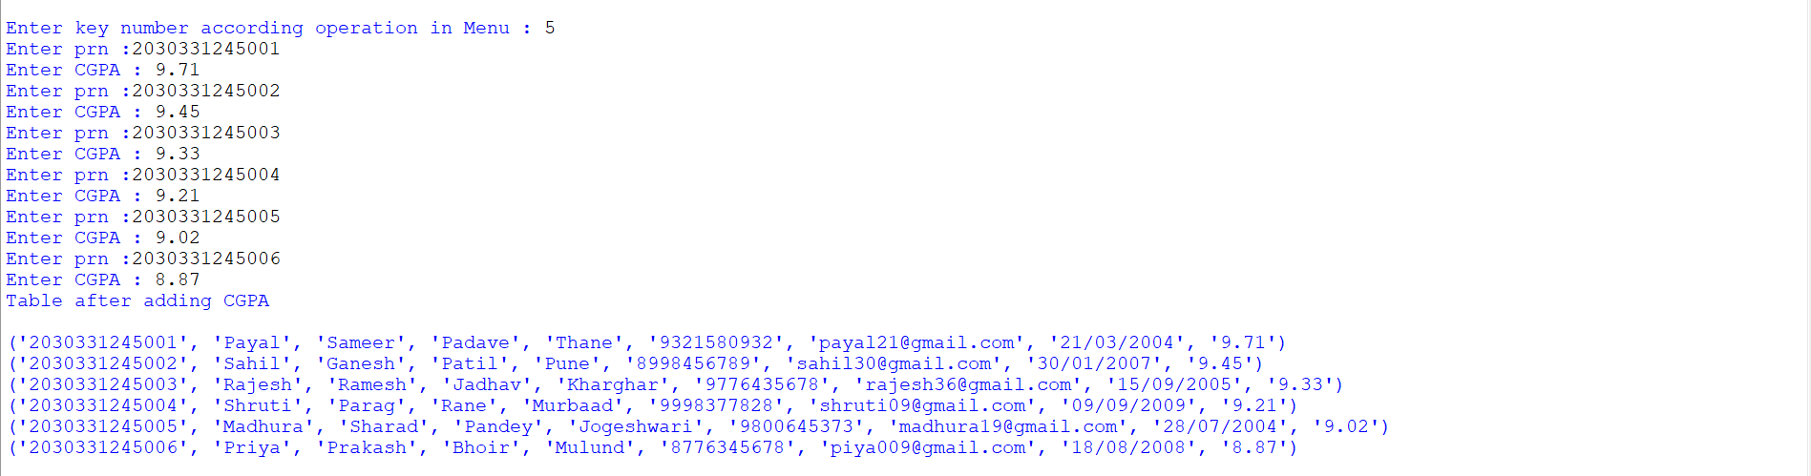

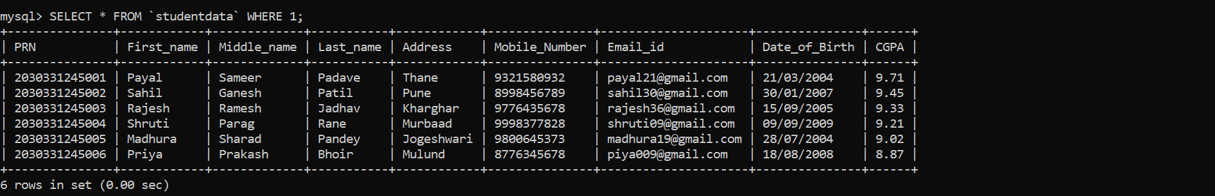

6) Display the final table

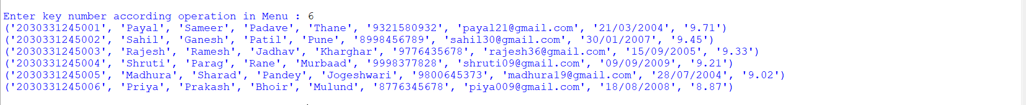



7)Exit

